This worksheet will help prepare you for the upcoming test. No part of this should be copy and pasted from the internet or another student. If it is, a zero will be assigned for violating the Academic Honesty Policy

If you need help with any parts related to “Supply” click on this link: [Supply Self-Paced Lesson](https://app.nearpod.com/?pin=JDPIA)

| 1. a) What is the law of supply?   The law of supply is a direct relationship between price and quantity supply where if stuff are sold at higher prices then there will be a higher supply  b) Explain how this graph illustrates the law of supply  This graph shows a direct relationship between the quantity supply and price and it shows higher the price higher the quantity supply |  |
| --- | --- |

1. Indicate what each graph represents in terms of supply

| Title For This:Change in quantity supplied  Explanation For What Is Happening:  When there is more supply of that good or service, the price is also increasing for that good or service.The quantity supplied is also increasing | Title For This:Change in quantity supplied  Explanation For What Is Happening:  When there less supply of that good or service, the price is also decreasing for that good or service.The quantity supplied is also decreasing |
| --- | --- |

3) Determinants of Supply

| Determinant of Supply | Your Explanation | Your Example |
| --- | --- | --- |
| Technological Advancements | Technological advancements will increase the efficiency of the product because more products are being created.It will shift the demand curve to the right | 1.Your good or service (not mentioned in the video or notes): News Apps  2. Photo of this good or service:  33 Best News Apps in 2021: Stocks, Sports, Business, Politics & More 📰  3. Explanation of the supply of this good going up or down because of this determinant of supply (underline where you state whether the good or service’s supply went up or down):  Due to an advancement in technology such as phones or any other website, the supply for paper newspapers will decrease while the supply for news apps will increase |
| Change in Resource Prices | When there is a shortage of a product the price of the product will increase due to a shortage of the product. It will shift to the left, the price will shift up and quantity supplied will shift to the left | 1. Your good or service (not mentioned in the video or notes):Xbox One X  2. Photo of this good or service:  Amazon.com: Microsoft Xbox One X 1Tb Console With Wireless Controller: Xbox  One X Enhanced, Hdr, Native 4K, Ultra Hd (Discontinued) : Video Games  3. Explanation of the supply of this good going up or down because of this determinant of supply (underline where you state whether the good or service’s supply went up or down):  The supply of the xbox one x decreased because producers could not afford to buy as much xbox one x and produce as many x box one x they could all because of supply shortages..The supply for x box one will go down/decrease |
| Change in Number of Producers | If the number of producers increase, the supply of that good or service will increase, if the number of producers decrease, the supply of that good or service will increase.When more businesses enter the market, there will be more supply of that good and service produced | 1. Your good or service (not mentioned in the video or notes): Fast Food Restaurants  2. Photo of this good or service:  Fast food restaurant - Wikipedia  3. Explanation of the supply of this good going up or down because of this determinant of supply (underline where you state whether the good or service’s supply went up or down):When there are more fast food restaurants around the area, the market supply of fast food will increase |
| Producer Expectations For Future Prices | When the company or producer know its a specific time of the year where more people wanna buy it, they decide to build more quantity and supply of that product and lower the price | 1. Your good or service (not mentioned in the video or notes):Swimsuits  2. Photo of this good or service:  Men's Swimsuits, Swim Trunks, Rash Guards, Board Shorts, Swim Shorts, Men's  Bathing Suits  3. Explanation of the supply of this good going up or down because of this determinant of supply (underline where you state whether the good or service’s supply went up or down): When the summer months hit,producers decide to produce more swimsuits in the summer, so more people can buy them. The supply for swim suits will go up in the summer |
| Change in Business Taxes or Subsidies | When there is a increase in tax rates on businesses companies or any sole proprietorship, it makes them lower vice versa or when the government provides subsidies, it prompts production increase | 1. Your good or service (not mentioned in the video or notes):  Electric Cars  2. Photo of this good or service:Electric Cars Could Save Ride-Sharing Drivers $5,200 a Year | Greentech  Media  3. Explanation of the supply of this good going up or down because of this determinant of supply (underline where you state whether the good or service’s supply went up or down): When the government decides to save money on gas fuel, they decide to produce more electric cars to keep our environment safe. The supply of electric cars goes up |
| Change in Price of Substitute Goods | When the popularity of a certain product increases the price of that product decreases and quantity supplied increases, the other products quantity decreases, and if the quantity decreases the price increases | 1. Your good or service (not mentioned in the video or notes):E Books  2. Photo of this good or service:How to Write an Ebook: 21 Dumb Mistakes to Avoid in 2021  3. Explanation of the supply of this good going up or down because of this determinant of supply (underline where you state whether the good or service’s supply went up or down):When producers produces more e books, then the the supply of regular books will decrease while the supply of e books will increase, because more people will have access to ebooks than regular books |
| Change in Price of Complementary Goods | When the price of a product that is used with another product increases the other products price also increases | 1. Your good or service (not mentioned in the video or notes): Shoes and socks  2. Photo of this good or service:Running Shoes and Socks. Vector Illustration Decorative Design Stock Vector  - Illustration of shoe, running: 189458340  3. Explanation of the supply of this good going up or down because of this determinant of supply (underline where you state whether the good or service’s supply went up or down):When the supply for shoes goes up, the supply for socks goes up because people have to wear socks to prevent it from coming on the shoes which will make it nasty. If the price of shoes go up, the price of socks will go up, they are both used together |

4) Increase in Supply Graph

Use Google Slides to create an increase in Supply Graph and insert a screenshot of your graph here

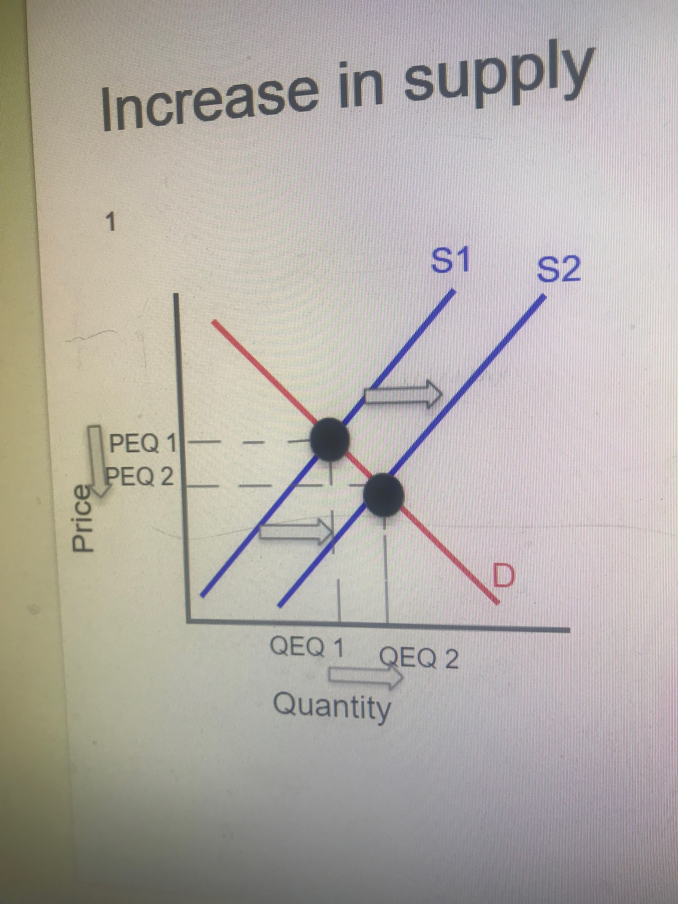

5) Decrease in Supply Graph

Use Google Slides to create an decrease in Supply Graph and insert a screenshot of your graph here

